(Approx. 1017 words)

Pay with your phone – Maybe soon, using Android Pay or Apple Pay
By Phil Sorrentino, Contributing Writer, The Computer Club, Florida
The Journal of The Computer Club, Inc.
http://scccomputerclub.org / Philsorr.wordpress.com
philsorr (at) yahoo.com

Android Pay and Apple Pay are payment services developed and supported by Google and Apple respectively. They both support in-app and tap-to-pay purchases on their respective mobile devices (phones, tablets, watches). You can use your phone for so many things already, why not add purchasing to the growing list? Your phone is usually in your hands anyway, why bother trying to get out your credit or debit card from your wallet or handbag, just use the phone to authorize the purchase. It’s really very easy and recent statistics indicate that either system can be used in over 700,000 stores in the US.

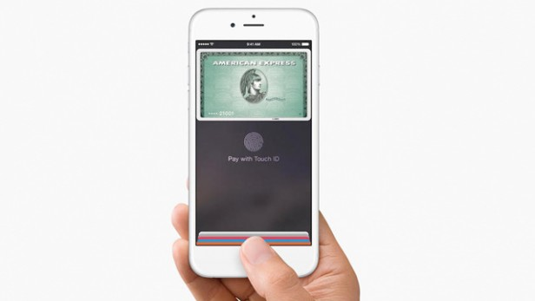

In-app purchases are purchases of extra content or subscriptions that you can buy while in an App, using your mobile device or computer. (Not all apps offer in-app purchases, but if they do, you will see “Offers In-App Purchases” or “In-App Purchases” on the app page possibly near the “price”, “buy” or “get” button.) In-App purchases may be consumable, like “game currency” or “game hints”, or non-consumable like “an Upgrade to a Pro Edition”, or an offer to “Remove Adds”. An In-App purchase may allow you to purchase a subscription to a newspaper, a magazine, a game, or even a service like Netflix.

Tap-to-Pay purchases are purchases you make at a store, at the Point-of-Sales (POS) terminal, using just your mobile device. (The POS terminal must be a contactless capable terminal.) Your mobile device takes the place of a credit or debit card or cash. Tap-to-Pay purchases are made by bringing the mobile device near the point-of-sale terminal and authorizing and starting the purchase by taping the terminal or possibly pressing a button on the device screen. In order to accomplish this, the device must have a Near Field Communications (NFC) capability built into the device. The Apple iPhone6, iPhone6Plus, iPhone6S, iPhone6Splus, or an iPhoneSE all have the capability built in. Android devices with version 4.4 Kit-Kat or higher are capable if they also have NFC circuitry in the device (check in Settings in your phone or check the user manual for your particular device). NFC is a set of short range wireless technologies and communications protocols that enable electronic devices to establish communication when brought to within 4 cm (1.6 in) of each other. (Communications protocols are a set of rules that allows two or more participants on a communications network to exchange information.)

So, believe it or not, in your smartphone there may be four different communications capabilities, each of which also includes an antenna. That little phone is really packed with electronics. Just for review, the communications capabilities are: NFC for very close communications, almost touching the phone, up to 1.6 in; Bluetooth, for a personal area network up to 10 meters around the device; Wi-Fi, a local area network up to maybe 100 meters; and of course, 3G or 4G Cell Phone Tower communications, capable of distances of up to 45 miles. (In populated areas, a cell tower may never be more than a few miles away, but in less populated areas the tower may be beyond the phone’s capability. Note that a typical cell phone has enough power to reach a cell tower up to 45 miles away, but depending on the technology of the network, the maximum distance may be as low as 22 miles, due to the timing requirements of the network.)

But back to paying with the phone. In order to make a purchase, you need the appropriate App, Android Pay for the Android phone and Apple Pay for the Apple phone (or Samsung Pay for certain Samsung phones). Once you have downloaded the App, you can add a credit or debit card to the App. You can use the camera to capture your card information or you can enter it manually. This is the card that will eventually be charged for the purchase. You can change the card to be used at any time. Although most cards from almost all U.S. banks can be used, some cards may not.

As with many new technologies, one of the biggest concerns with something like Apple Pay or Android Pay is security. And so, one of the reasons you may want to use your phone for a purchase is because of the improved security over a similar transaction made by a credit or debit card. The purchasing process is a little different in that your card information is never used during the transaction. Instead, a virtual account number, or one-time transaction code is created and used for the transaction, in place of your true card information. The transaction code can only be used once, and may even expire after a set period of time. Additionally, fingerprint ID authentication is used on devices where a fingerprint reader is available. On devices without a fingerprint reader the purchase is authorized with a password (great, another password to remember). So, if this system provides better security because of the way it works and if it is more convenient than using a credit or debit card, this may be the way many future purchases will be made.

By the way, Android Pay is different from Google Wallet. Wallet is not for purchasing, it is a peer-to-peer method of transferring money to another person. As the advertisement for Google Wallet states “Google Wallet is a fast, free way to send and request money. You can send money to someone using just their email address or phone number – they don’t need to have the Wallet app. All you need is a Google Account and a debit card to get started.” And let’s not forget that Apple has recently announced a Peer-to-Peer mobile payment service that will be in the new iOS 11 Operating System. These money transfer systems may just be an indication of a world that has become more dependent on mobile devices and less reliant on cash for transactions.

